Notes/Tips from previous Honey Shows

Here are some hints for members who are new to showing about how to make successful entries. They are based on judges' comments on exhibits seen in previous shows so should be quite helpful.

MOST IMPORTANT - Read the Schedule and avoid errors when preparing entries

Filling of Honey Jars

Weights – With many makes of honey jar available  and their varying weights (up to 20g in some cases)  the only way to be certain that the jar contains  454g (1lb) of honey is if there is no air gap visible  between the surface of the honey and the lower  edge of the lid.  Make sure lids are not too tight. Vaseline around the rim stops white powder from the lid falling in the jar. | 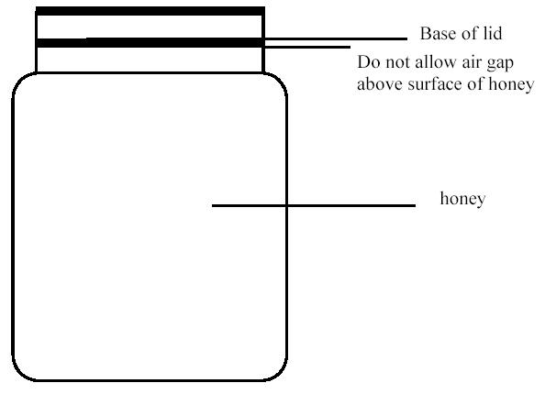
Honey Classes in general
- Read the schedule carefully and enter your honey in the right class. (If you aren’t sure about: Light, Medium, and Dark then bring it along and someone will help
- The judge is primarily judging the honey so make sure that the honey is well prepared. Filter out any bits and make sure that run honey is sparkling clear. Shine a big torch through the bottom of the jar as this highlights any bits still in there. Also make sure your set honey really is set.
- Make sure that your jars and lids are clean and free from faults. It’s a good idea to use matching jars in classes for 2 jars or more. Look underneath for two jars with the same manufacturer’s marks. Make sure too that the jars are full. You shouldn’t be able to see the top of the honey when the lid is on (see diagram above)
- If you enter the classes ‘As for Sale’ and ‘Gift Honey’ and you aren’t sure about labelling then bring your jars and labels along and someone will try to help. It’s worth looking at http://www.bbka.org.uk/articles/honey_labels.php. The judge will open these entries so don’t apply anti-tamper labels until after the show.

Runny Honey (Light/Medium/Dark)
- Important that honey is not too thin (water content maybe marginally too high).
- Try to remove excessive bubbles (can be done by heating gently) this also gets rid of any haze
- Avoid wax particles in the honey.
- Avoid having crystals forming in the bottom of the jar

Granualted/Soft Set Honey
Marbling effect is acceptable, although it may indicate that the jars were perhaps cold when the honey was poured in. To avoid this, warm the jars before filling.

Cut Comb
The comb and cappings should be as white as possible with no granulated cells, and no pollen in evidence.
In most honey shows, two containers of cut comb are called for, and these should be matching.
How do you cut honey from the same comb?
- They should therefore be cut from the same comb, with the cells running in the same direction. The face of the comb should be level and evenly capped, and care must be taken that there is no damage by wax moths.
- When cutting the comb, the cells severed by the process will obviously ooze honey. This should be allowed to drain off before placing the piece of comb into its container.
- The weight of the comb is governed by the density of the honey and the thickness of the comb, but most schedules allow for a modest variation.
Clearly, if the schedule calls for approximately 8ozs, there is little point in entering a 12oz container
How is a cut comb inspected?
- The containers used are usually the standard 8oz white plastic Cut Comb Containers or “all-clear” Combined Lid & Container. The comb should fit the container fully and snugly, but allowing for easy removal by the judge, who will want to inspect the underside. (No room for anything sneaky there then).
- To ensure the correct size, a plastic template is useful, cut from a margarine container or something similar, and don’t forget to trim the corners.
- A cut comb is inspected much as whole comb, for crystals (none) pollen, colour, taste and aroma. For entries in white plastic containers, the judge always tips the comb out to see the other side or will turn the clear container over to see the other side, so does not want any loose liquid in the box. General points as for other comb + good clean box.
Frames
- Use a frame that has a nice clean “top-bar” and make sure the glass of the showcase is clean and free of smudges. Appearance is always important, and could be the deciding factor if two frames are of similar quality and judge has to decide which is best.
- Frames must be shown inside a protective display stand so that passing bees and wasps aren’t attracted

Wax
  - Should be good quality, well-filtered wax, matching the brief as in the schedule for weight and thickness.
  - All exhibits will be staged on a white plate provided by the Association

Candles.
  - You should use a very good wax, as appearance matters.
  - Your candles should be straight
  - It’s important to have the right size wick, so that the candle remains lit and will pass the re-light test.
  - Stage your candles in a suitable candle-holder so that when the judge lights one he doesn’t get hot wax over his hands (ouch!)
  - Run candle bottoms over a hot plate to get even bottoms.

Cakes
The Honey Fruit Cake is a very difficult recipe which makes for real competition and good judging.
Mix the ingredients well as the fruit should be evenly distributed throughout the cake. Also, it can quickly burn so you need to take care with your timings. Those given in the recipe may need to be adjusted to suit your own oven.

Novice Classes
You may enter the Novice section if you have not won a prize in any other section in previous shows.

Children’s Entry - Flapjacks
Choose your best 5 pieces - but remember it’s important to try to keep the pieces of even size and have a nice colour.

Childrens' Entries – Artwork
- Can be on any subject connected to bees and/or beekeeping
- Can be in any medium – painting, drawing, modelling, etc
- Can be made by a child any age below 16 – no membership required!!

