Honey Show Schedule 2024
Saturday 5th October
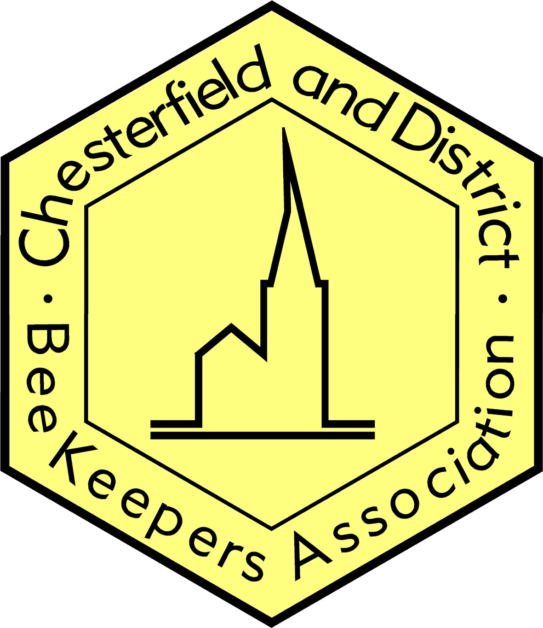 |  | All entries should be made in advance by 8pm Thursday 3rd October. (You may withdraw from classes up to 5pm Friday 4th October by notifying the Paula Conway, Show Secretary plaggy218@gmail.com
Tick classes to enter |  | All entries to be available for staging between 6:30 and 8 pm Friday 4th October
 |  | Late staging may be permitted between 8:00 and 8:30am on Sat 5th October only by prior arrangement with the Show Secretary but new entries will not be permitted.
 |  | All classes are open to members and non-members. Only 1 entry in each class per person.
 |  | ENTRANT NAME:
 |  | Honey Classes
 |  | H.A | Light Honey (2 jars) | Standard 1lb squat jars. We accept use Metal or Plastic (White or Gold) Lids, just make sure they are "matching" |  | "Entry label" to be placed 20mm from bottom of the jars. NB: We will have measuring blocks available to enable you place your label correctly.
 |  | H.B | Medium Honey (2 jars)
 |  | H.C | Dark Honey (2 jars)
 |  | H.D | Granulated Honey (2 jars)
 |  | H.E | Soft Set Honey (2 jars)
 |  | H.F | Heather Honey (2 jars)
 |  | H.G | 3 jars (one of each from any of classes H.A-H.F)
 |  | H.H | 6 jars of Honey (of same type) as offered for sale | Front label only, NO tamper label
 |  | H.I | 6 jars of Honey (of same type) as offered for sale in jars other than 454 Gram Squat
 |  | H.J | 1 jar of Honey to be “Blind” judged by Smell & Taste. | Standard 1lb squat jars. We accept use Metal or Plastic (White or Gold) Lids,  Black Wrapper supplied
 |  | H.K | 1 Shallow Frame of Capped Honey |  |  | Entry label to be placed at bottom right of the frame
 |  | H.L | Uniform Pair of Cut Comb (Gross wt 7-9oz /200-255g) | Plastic Containers & Lids are available (if required) |  | Entry labels to be placed at bottom right of both boxes
 |  | H.M | Gift - 1 jar Runny Honey (To be labelled as for class H.H or H.I) | Front label only, NO tamper label |  | "Entry label" to be placed 20mm from bottom of the jars. NB: We will have measuring blocks available to enable you place your label correctly.
 |  | H.N | Gift - 1 jar Granulated Honey (To be labelled as for class H.H or H.I)
 |  | H.O | Gift - 1 jar Soft Set Honey (To be labelled as for class H.H or H.I)
 |  | H.P | Gift - 1 jar Heather Honey (To be labelled as for class H.F) | Front label only, NO tamper label |  | "Entry label" to be placed 20mm from bottom of the jars. NB: We will have measuring blocks available to enable you place your label correctly
 |  | Novice Classes
 |  | N.A | 2 jars of Runny Honey | Standard 1lb squat jars. We accept use Metal or Plastic (White or Gold) Lids, just make sure they are "matching" |  | "Entry label" to be placed 20mm from bottom of the jars. NB: We will have measuring blocks available to enable you place your label correctly.
 |  | N.B | 2 jars of Granulated Honey
 |  | N.C | 2 jars of Soft Set Honey
 |  | N.D | Two blocks of Beeswax weighing not less than 28g (1oz) | Containers supplied
 | Wax Classes
 | W.A |  | One Cake of Wax (227g or more) |  | Display case supplied |  | Entry label to be placed on bottom right of box
 | W.B |  | One Cake of Wax (350g or more) prepared for commercial purpose
 | W.C |  | One Cake of Wax (454g or more and min 25mm thick)
 | W.D |  | An article of Beeswax made from not more than 227g wax |  |  |  | Entry label to be placed on bottom of article
 | W.E |  | 2 matching Beeswax candles, moulded, on a plain safe holder, 1 to be lit by the Judge |  |  |  | Entry labels to be placed at the bottom front of both candles
 | W.F |  | 2 matching Beeswax candles, dipped, on a plain safe holder, 1 to be lit by Judge
 | W.G |  | 1 container of polish as presented for sale |  |  |  | Entry label to be placed on front of lid
 | Consumables Classes
 | C.A |  | Mead - 1 bottle of Sweet Mead |  | Clear, colourless 75cl bottle with removable cork stopper |  | Entry label to be placed 20mm from bottom of the bottle jars
 | C.B |  | Mead - 1 bottle of Dry Mead
 | C.C |  | Melomel - 1 bottle
 | C.D |  | Honey Fruit Cake (“Jubilee Rose Bowl”) |  | Display case supplied |  | Entry label to be placed on front of plate
 | C.E |  | Honey Cherry Cake (Trevor Dolby Memorial Cup) |  | Display case supplied
 | C.F |  | Cosmetic article or soap made from a hive product
 | Photography Classes
 | P.A |  | A photograph of Honeybees or Honeybee – with caption, not larger than 200mm x 150 mm (approx 8" x 6") |  | On a mount not larger than 300mm x 210mm (A4)  254mm x 203mm  (10”x8”) are available from Max Spielmann |  | Entry label to be placed on front, bottom right
 | P.B |  | A photograph of Beekeeping – with caption, not larger than 200mm x 150 mm (approx 8" x 6")
 | P.C |  | A photograph of Bee or Bees other than Apis Mellifera – with caption, not larger than 200mm x 150 mm (approx 8" x 6")
 | Junior Classes
 | J.A |  | 11 and under; A Handmade Exhibit of Bees or Beekeeping |  |  |  | Entry label to be placed on front, bottom right
 | J.B |  | 12 - 16; A Handmade Exhibit of Bees or Beekeeping
 | J.C |  | Honey Flapjack |  | Best 5 Bars  Display case supplied

